Interface Program Implementation
1. Write a java program with interface and class by declaring object for Interface.

interface I1
{
int a=5;
void display();
}
class Main implements I1
{
public void display()
{
System.out.println("Display Method");
}

public static void main(String args[])
{
I1 m=new Main();
m.display();
System.out.println("InterFace implemented Class");
}
}
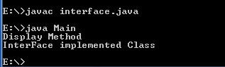
2. Write a java program with interface and class by declaring constructor for Interface.

interface I1
{
int a=5;
void display();
I1();
}
class Main implements I1
{
public void display()
{
System.out.println("Display Method");
}

public static void main(String args[])
{
I1 m=new Main();
m.display();
System.out.println("InterFace implemented Class");
}
}
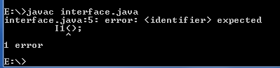

3. Write a java program with interface and class by declaring static for Interface.
interface I1
{
int a=5;
void display();
static
{
}
}
class Main implements I1
{
public void display()
{
System.out.println("Display Method");
}

public static void main(String args[])
{
I1 m=new Main();
m.display();
System.out.println("InterFace implemented Class");
}
}

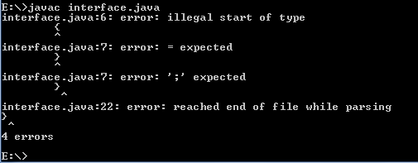

4. Write a java program with interface and class by declaring variable or method with different access specifier (Except default and public).

interface I1
{
int a=5;
protected void display();
}
class Main implements I1
{
public void display()
{
System.out.println("Display Method");
}

public static void main(String args[])
{
I1 m=new Main();
m.display();
System.out.println("InterFace implemented Class");
}
}
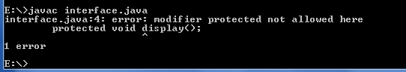

5. Write a java program with interfaces (I1,I2,I3) and class implementing all the interfaces.

interface I1
{
int a=5;
void display();
}
interface I2
{
int a=23;
void display();
}
interface I3
{
int a=35;
void display();
}
class Main implements I1,I2,I3
{
public void display()
{
System.out.println("Display Method");
}

public static void main(String args[])
{
Main m=new Main();
m.display();
System.out.println("InterFace implemented Class");
}
}
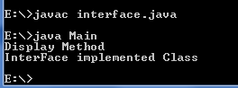

6. Write a java program with interfaces (I1,I2 extends I1,I3 extends I2) and class implementing all the interface I3.
interface I1
{
int a=5;
void display();
}
interface I2 extends I1
{
int a=23;
void display();
}
interface I3 extends I2
{
int a=35;
void display();
}
class Main implements I3
{
public void display()
{
System.out.println("Display Method");
}

public static void main(String args[])
{
Main m=new Main();
m.display();
System.out.println("InterFace implemented Class");
}
}
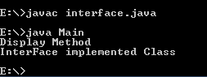
7. Write a java program with interfaces (I1,I2,I3 extends I1,I2) and class implementing all the interface I3.
interface I1
{
int a=5;
void display1();
}
interface I2
{
int a=23;
void display2();
}
interface I3 extends I1,I2
{
int a=35;
void display3();
}
class Main implements I3
{
public void display1()
{
System.out.println("Display Method1");
}
public void display2()
{
System.out.println("Display Method2");
}
public void display3()
{
System.out.println("Display Method3");
}

public static void main(String args[])
{
Main m=new Main();
m.display1();
m.display2();
m.display3();
System.out.println("InterFace implemented Class");
}
}

